**Finding Largest Number**

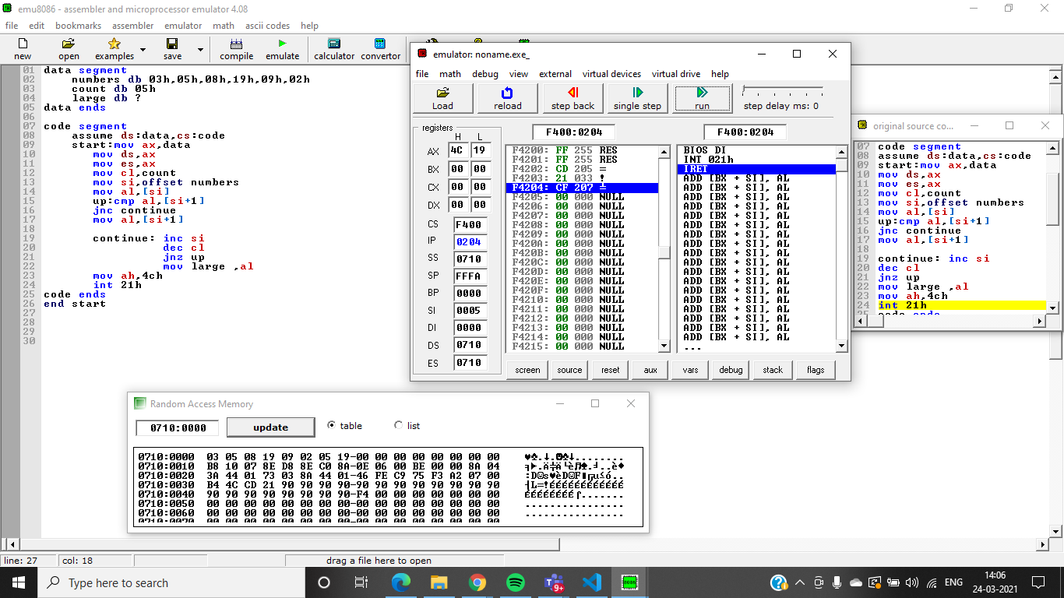

data segment

numbers db 03h,05h,08h,19h,09h,02h

count db 05h

large db ?

data ends

**Ascending order sorting**

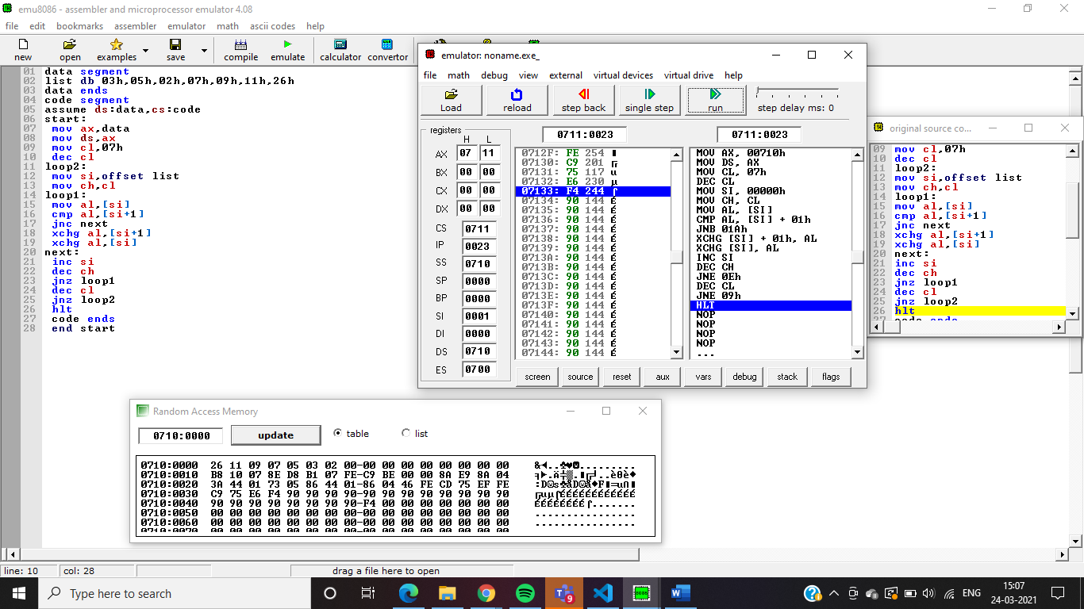

code segment

assume ds:data,cs:code

start:mov ax,data

mov ds,ax

mov es,ax

mov cl,count

mov si,offset numbers

mov al,[si]

up:cmp al,[si+1]

jnc continue

mov al,[si+1]

continue: inc si

dec cl

jnz up

mov large ,al

mov ah,4ch

int 21h

code ends

end start

data segment

list db 03h,05h,02h,07h,09h,11h,26h

data ends

code segment

assume ds:data,cs:code

start:

mov ax,data

mov ds,ax

mov cl,07h

dec cl

loop2:

mov si,offset list

mov ch,cl

loop1:

mov al,[si]

cmp al,[si+1]

jnc next

xchg al,[si+1]

xchg al,[si]

next:

inc si

dec ch

jnz loop1

dec cl

jnz loop2

hlt

code ends

end start

**Descending Order Sorting**

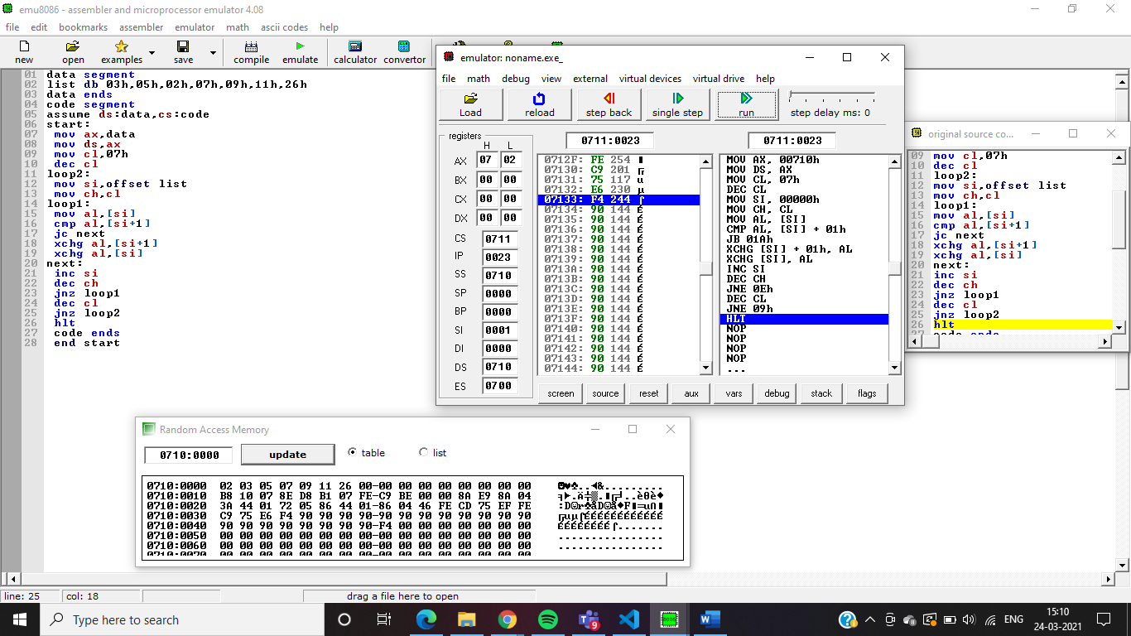

data segment

list db 03h,05h,02h,07h,09h,11h,26h

data ends

code segment

assume ds:data,cs:code

start:

mov ax,data

mov ds,ax

mov cl,07h

dec cl

loop2:

mov si,offset list

mov ch,cl

loop1:

mov al,[si]

cmp al,[si+1]

jc next

xchg al,[si+1]

xchg al,[si]

next:

inc si

dec ch

jnz loop1

dec cl

jnz loop2

hlt

code ends

end start